The maps look good and the info file for the deeds look good however, it looks like it only pulled page one of each deed which is not the correct page. It also looks like it didn't find the particular section block that you typed in and lot in the system and it pulled the section block and lot from the input and not from the panel on the left. For example file N-10-10-5-01-28-1993-20240723191545.jpg is actually N-10-100-518 The section block and lot are correct in the csv file but the file is not named correctly. The deeds are multi page as well, take a look at the attached images. The important info is never on page one, its usually somewhere in the middle of the deed.

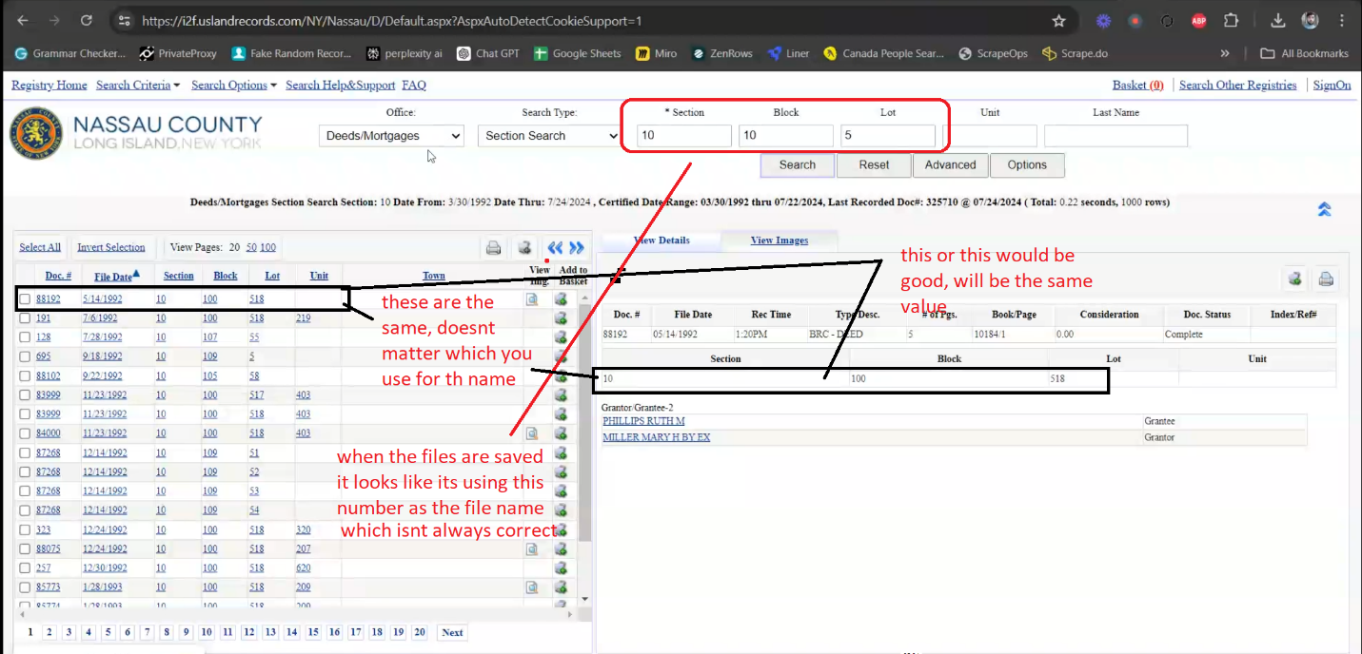

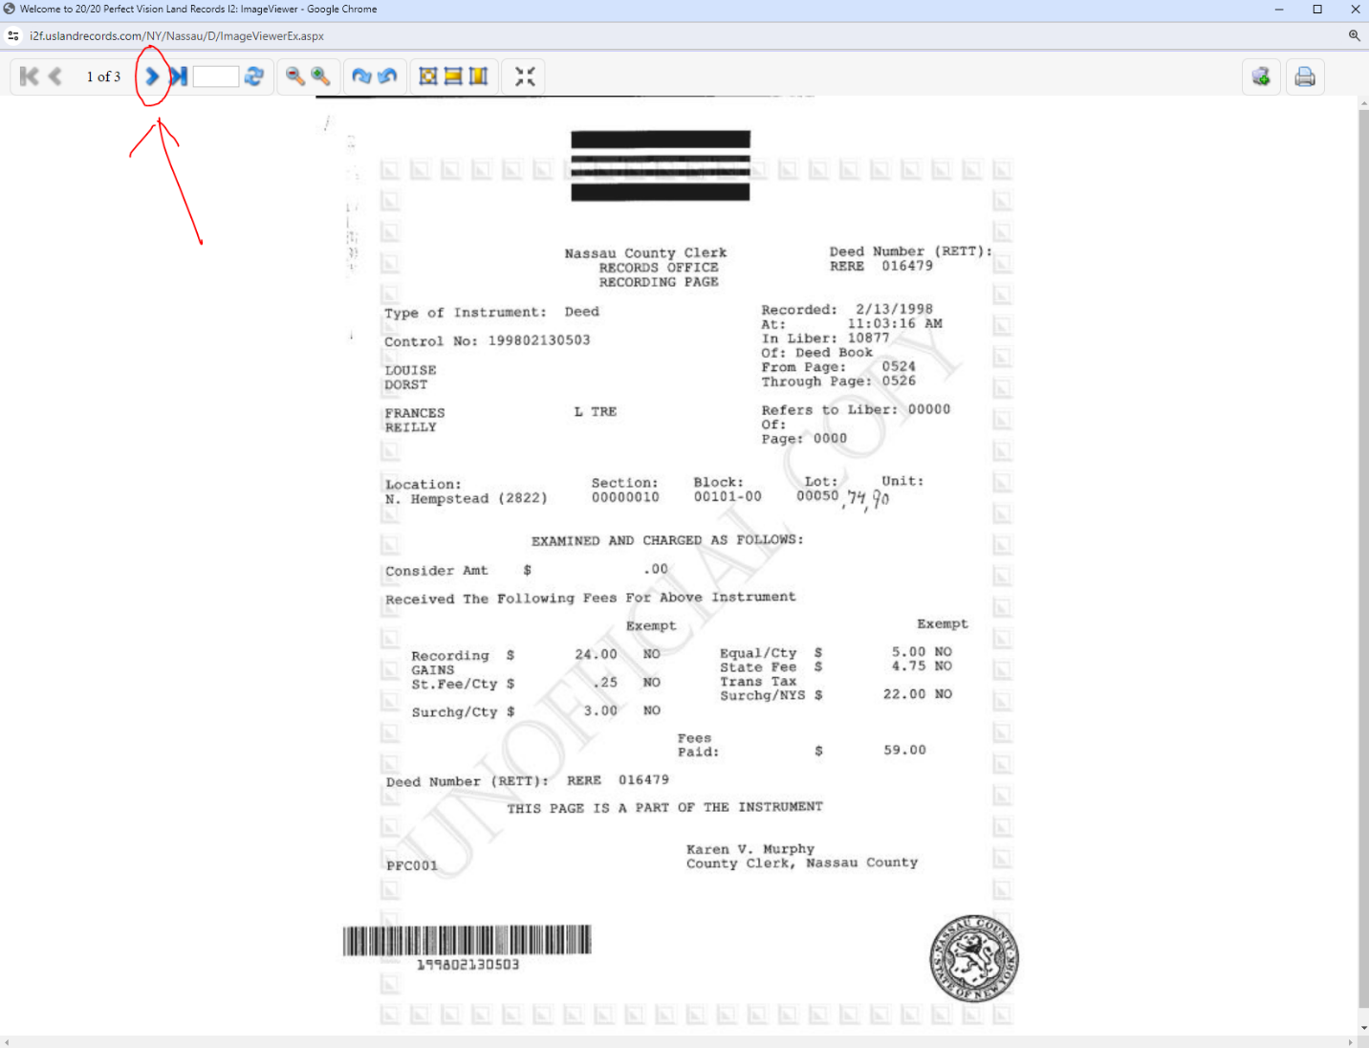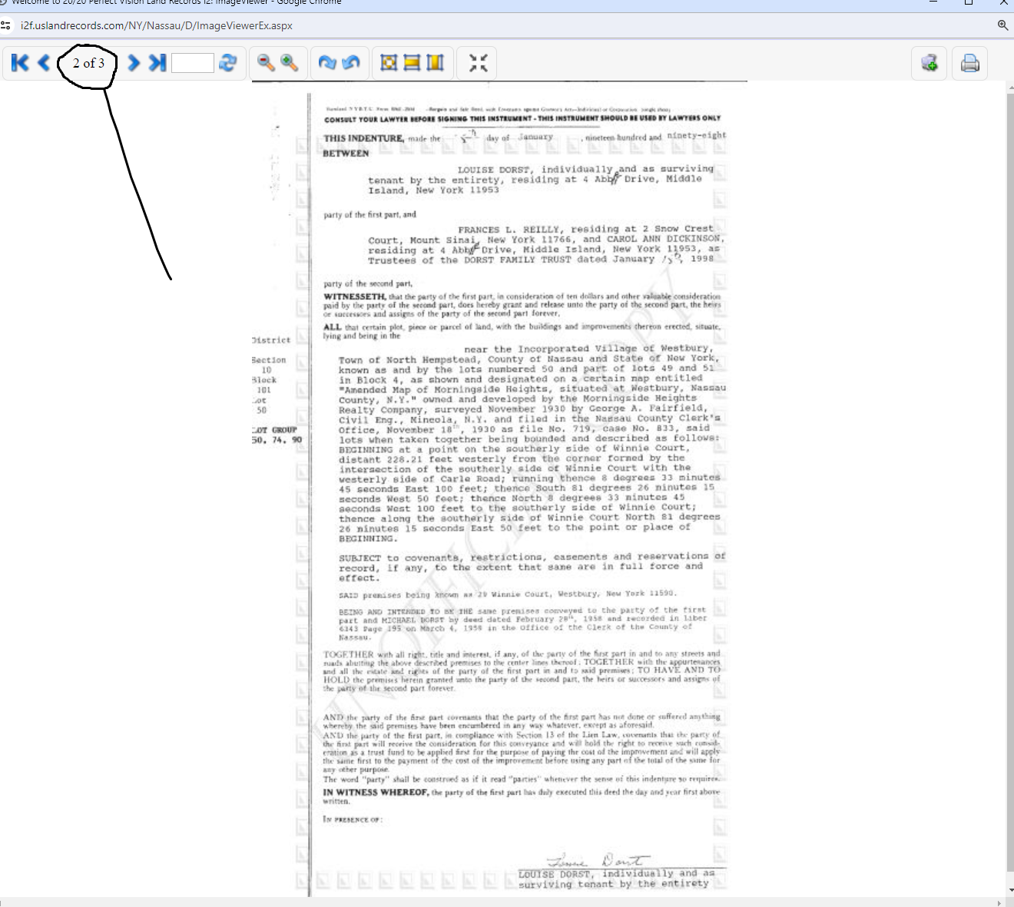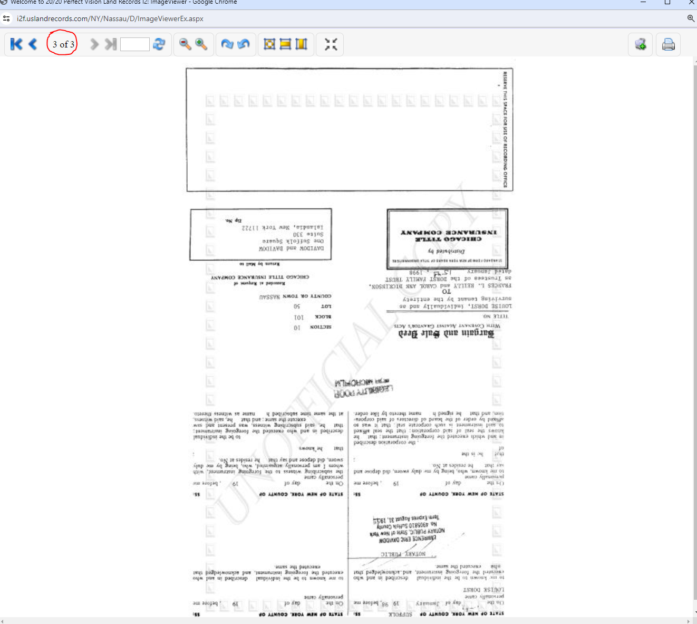

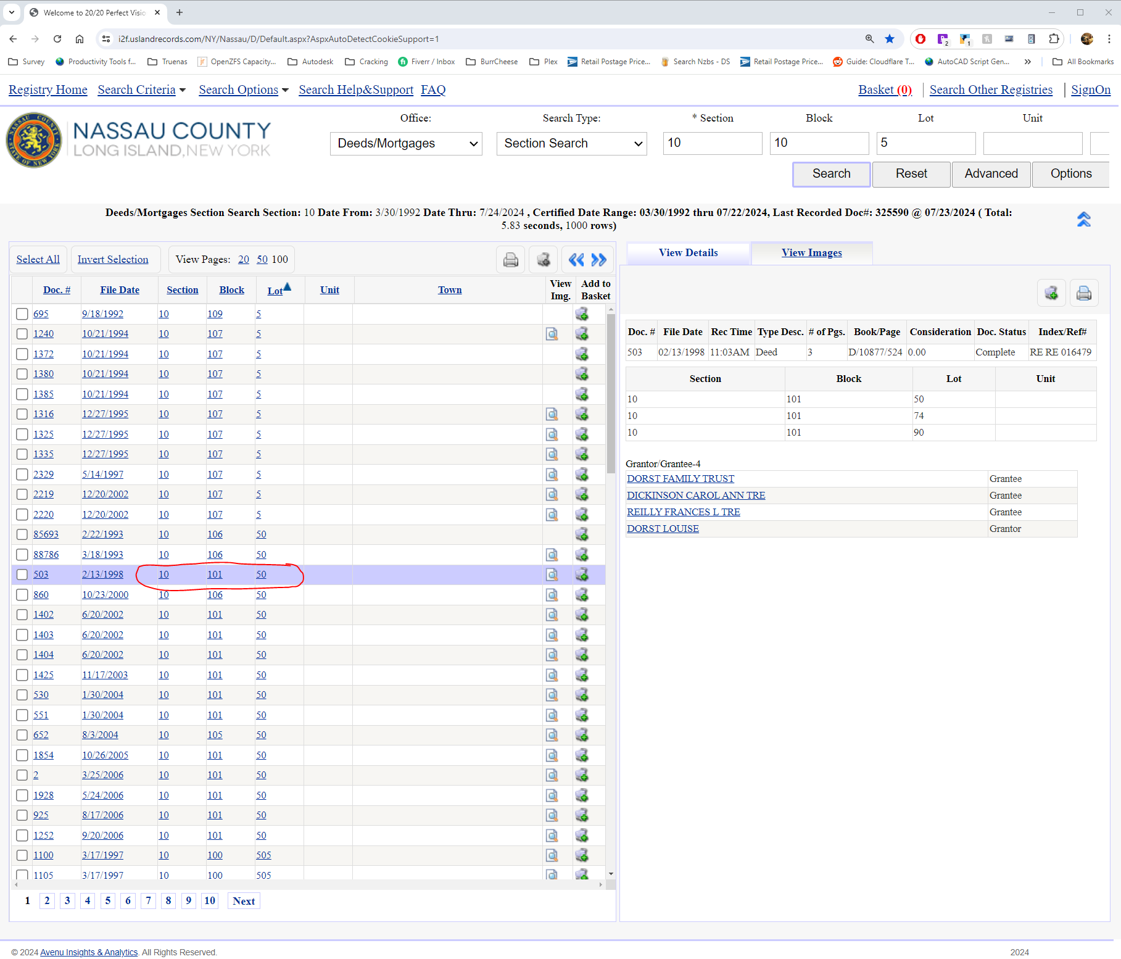

with the deeds yes if there are multiple pages for example 5 then pull all 5 pages and combine into one pdf. There is no way to know which page the important info is going to be on.

One last request, when you name the maps, can you use the values from the map title column, file date, and map no column, don't need all those numbers after the map name. The file name should be:

**Map No - Map Title - File Date**

I don't think the resolution changed between the samples but i can read out most of the numbers and this will be very helpful. Without seeing the script. When it generates the URL's to download the files can those values of CNTWIDTH, CNTHEIGHT, and Height&ZOOM be changed to 2557, 963, 4.5 respectively and the page be redownloaded with those values

I thought of a possible workaround for the resolution issue. As each file is scraped can you have the script export a text file unto a url folder with 2 things in it for each one. The filename the file will be saved as and the url. I could then write a python script to do a find and replace on those resolution and zoom values. Have it monitor then folder and wget them as they pop up the links are generated as needed and I'm not sure how long they stay live for I haven't tested it. But I do know if you try to refresh the page after an hour or two the link is down. It's probably only up for a few minutes after being generated. Maybe it will pull them in full resolution. Just a thought. Not sure why changing those values in scrappy isn't affecting the output resolution. I do know that when the page loads it sets the resolution values based upon the resolution of the size of the pop up window with the images in it. Through trial and error I figured out those values after noticing how they changed them when I would pull maps on my 1080p laptop vs my 4k desktop screen.